PREPARATION AND
MAINTENANCE OF ZOHOBOOKS
FOR
TECHPRO SOLUTIONS
INTRODUCTION:
ZOHO BOOKS is an online accounting application that gives you complete visibility of your finances and helps you manage the money moving in and out of your business.
Zoho books can simply be defined as “accounting for rest of us”. you need not be an accountant to manage your business and make informed financial decisions.
OBJECTIVES:
What is the objectives of zoho books?
Zohobooks is your one –stop platform for managing your accounting tasks and organizing your transactions. It’s a single secure location to keep up with your company’s bills and invoices , reconcile your bank statement , control your spending , oversee projects , and eliminate sales tax compliance worries.
Why do we need zohobooks?
It allows you to manage your projects from budgeting to logging time and invoicing customers effectively. Moreover, zohobooks software lets you record the time spent on tasks and avoid overbilling and underbilling your customers.

PROBLEMS:
EMPATHY Map:
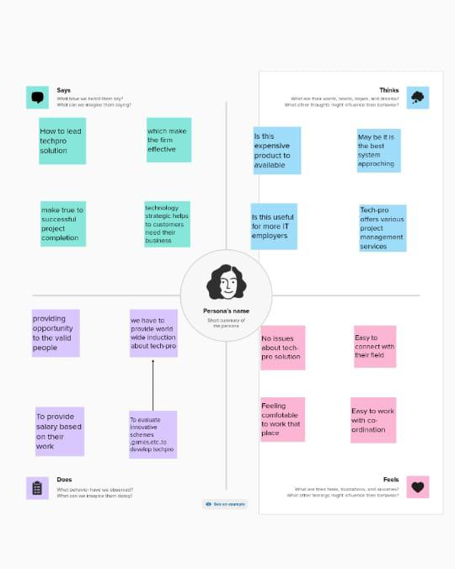

BRAINSTORMING:
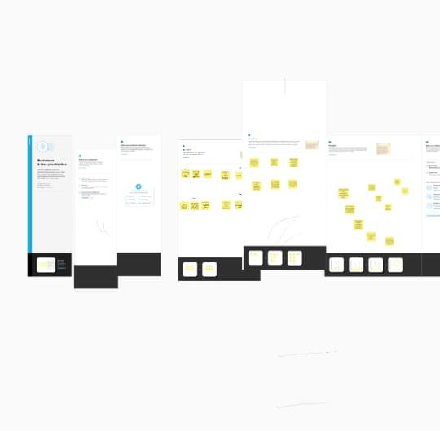

FEATURES:
FUNCTIONS IN PROJECTS
Create and Send Project Quotes.
Invoice Customers for Projects.
Record Project Expenses.
Create Retainer Invoice for Projects.
Bill the Vendors for a Project.
Manual Journals.
Bulk Update Line Items.
Track Transactions.
- Invoicing And Billing
Invoicing and billing are essential business functions and the primary source of cash flowing into your business. However, managing invoices manually is time-consuming and error-prone. It is also challenging to track invoices and remind customers of pending payments without automated software. ZohoBooks addresses these issues effectively and offers you great features that make your invoicing easier.
For example, it enables you to create recurring profiles for regular customers and outstanding invoices that can be sent out automatically to your customers when an order is placed.
Moreover, ZohoBooks allows you to automate your payment reminders and track due dates and expected payment dates. So, it can send them to your customers automatically.
- Online Payments
Collecting payments from clients can be difficult if you don’t have a proper system. With ZohoBooks Software, you can integrate your accounting system with various online payment gateways that offer clients a fast and secure means of paying you. Thus, online payment gateways automatically record payments you receive and update them under the corresponding invoice in your accounting system. In addition, you can handle all kinds of currencies and connect your accounting application with ZohoBooks to support multiple currencies.
3. Expense Tracking
With ZohoBooks, you can effortlessly track your expenses and get a robust grip on your cash flow. It helps you to keep tabs on your costs and categorize them to get a complete picture of where your money is going. Besides, you can easily upload expense receipts, scan them and record all information automatically. With ZohoBooks Software, you don’t need to store paper records and the risk of losing them. 4.Bank Reconciliation
Bank Reconciliation is the core accounting feature that can be easily streamlined by using ZohoBooks Software. You can easily connect your bank accounts with ZohoBooks and easily fetch statements from bank feeds automatically into your accounts. You can also set up custom criteria in your accounting application to categorize and match imported bank transactions automatically. Besides, ZohoBooks Software keeps your business audit-ready all over the year.
5. Project Management & Timesheets
ZohoBooks Software helps you track your project’s pace, identify bottlenecks, and resolve them quickly. It allows you to manage your projects from budgeting to logging time and invoicing customers effectively. Moreover, ZohoBooks Software lets you record the time spent on tasks and avoid overbilling and underbilling your customers. So keep everyone on the same page!
6. Inventory Management
ZohoBooks Software gives you the best inventory management system to record your item information, track items, account, and generating reports. Additionally, Best Accounting Software will help you add item images, create bundles, track object’s movement with serial and batch numbers, and record stockkeeping unit codes easily. You can also track stock and set reorder levels for your goods to receive automated emails. Moreover, ZohoBooks helps you generate inventory-specific reports to better insight and manage the inventory system more effectively.
7. VAT Tax Compliance
ZohoBooks is built to adhere to your local tax regulations and make working with taxes easier. It can make calculating taxes faster and help you apply the correct tax to your transactions more accurately. With ZohoBooks Software, you can better understand your taxes by generating tax summary reports and stay prepared for tax time. In addition, ZohoBooks VAT-ready software manages your finances and keeps you VAT compliant.
8. Report Generation
Let’s make the right decisions and ensure that your organization’s health is good. ZohoBooks allows you to understand your business’s financial trends and analyze growth patterns. However, ZohoBooks consolidate data and make your report generation processes easier. As a result, you can save time creating incredible accounting reports.
9. Reduce Overall Costs
ZohoBooks Software can reduce the overall costs and allows your accounting team to do more in a given time. It has a cost control and reduction program to increase your profit and manage your day-to-day operations. Track and measure the operational productivity of your business and modernize your accounting processes with ZohoBooks.
10. Minimizes Data Lost
With ZohoBooks, you can store your financial data in the cloud. In addition, it empowers your team to restore all data and reduce data loss risk.
Always backup your data.
Encrypt sensitive data.
Address data security
DISADVANTAGES:
- Monthly transaction cap.
- Multiple subscriptions for multiple businesses. Additional users require a fee.
- Fewer integrations than competitors.
- No payroll services.
- Accounts payable limitations.

CONCLUSION: To conclude, ZohoBooks is easy to understand and its configuration is quick and easy. The automation of the system is great and you save a lot of time.

